**1. create all given tables**

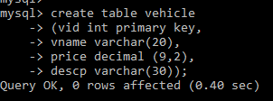

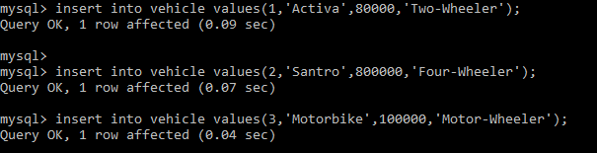

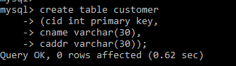

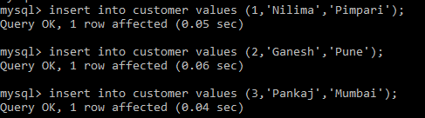

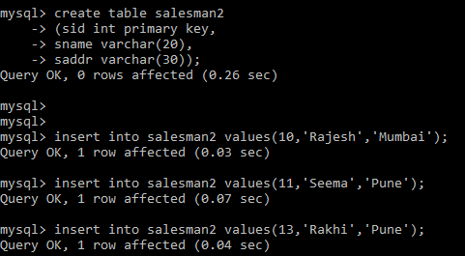

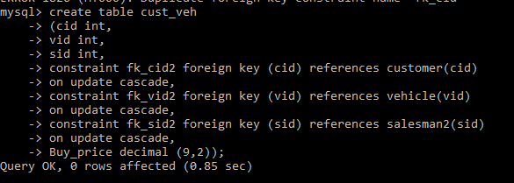

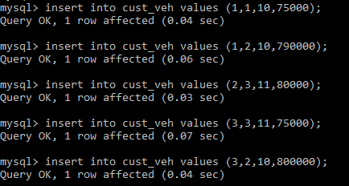

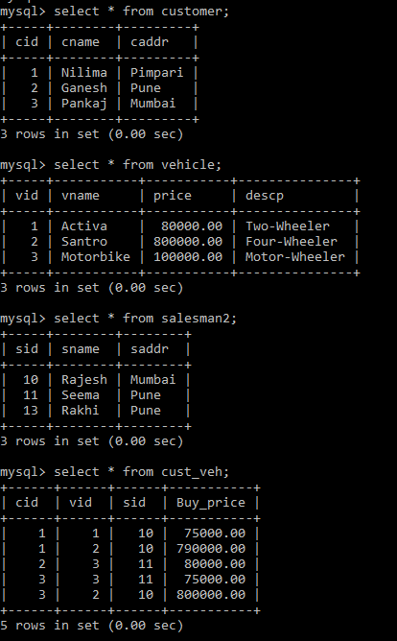

**2. create index on vehicle table based on price**



**3. find all customer name,vehicle name, salesman name, discount earn by all customer**

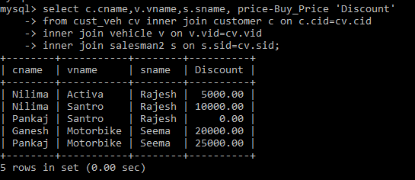

**4. find all customer name,vehicle name,salesman name for all salesman who stays in pune**

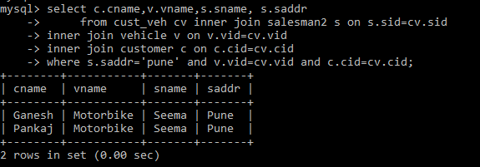

**5. find how many customers bought motor bike**

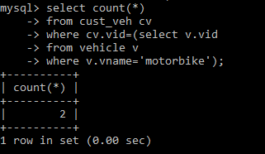

**create a view find_discount which displays output**

**-------to create view**

**--------to display discount**

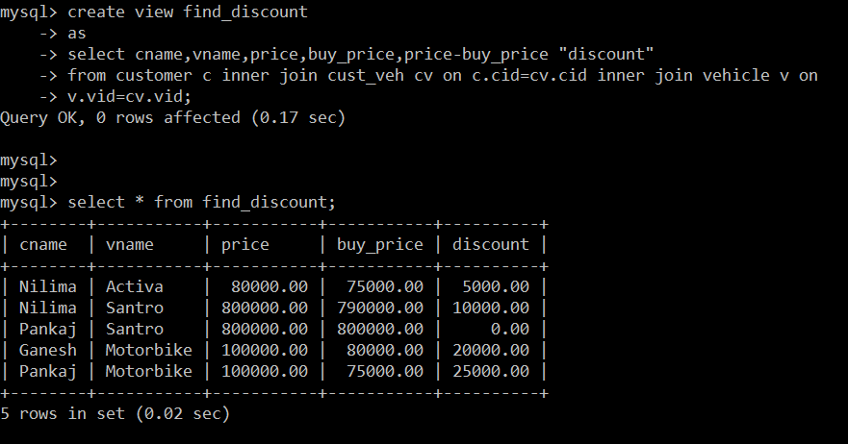

**8. create view my_hr to display empno,ename,job,comm for all employees who earn commission**

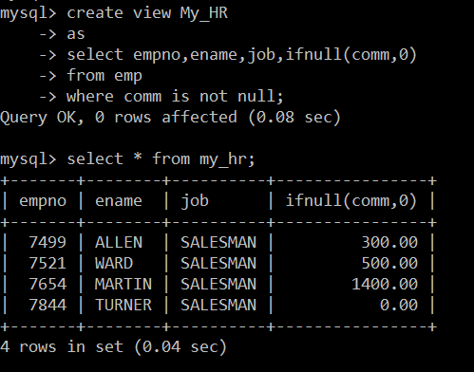

**9. create view mgr30 to display all employees from department 30**

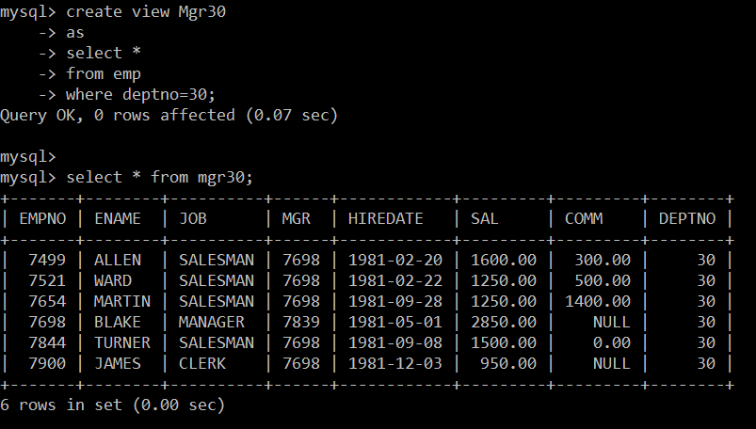

**10. insert 3 employees in view mgr30 check whether insertion is possible**



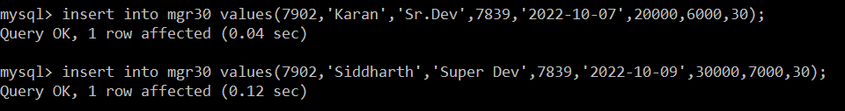

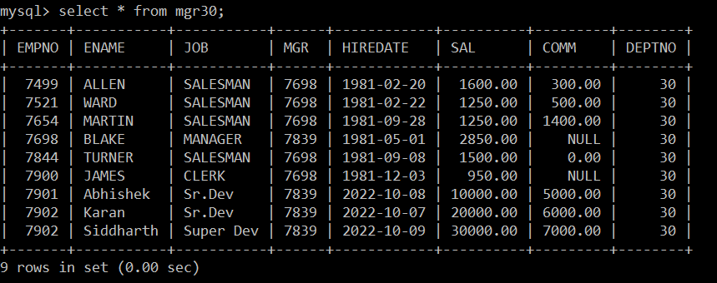

**11. insert 3 records in dept and display all records from dept**

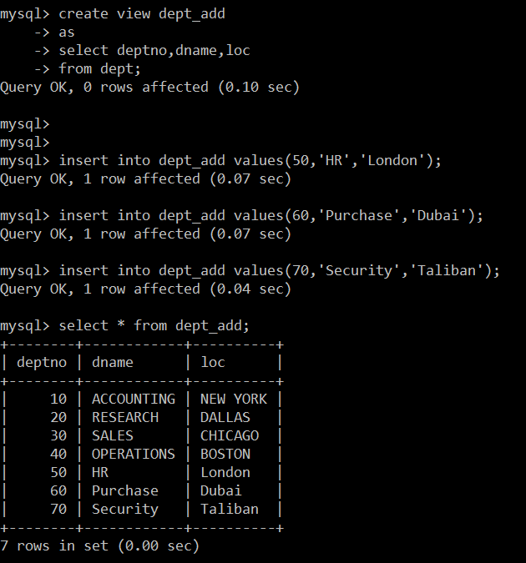

**12. use rollback command check what happens**

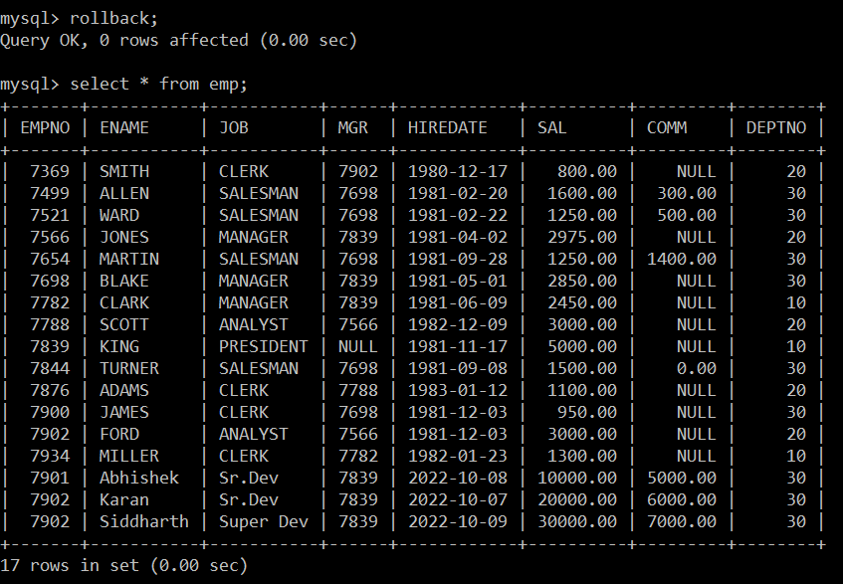

**13. do the following**

**insert row in emp with empno 100**

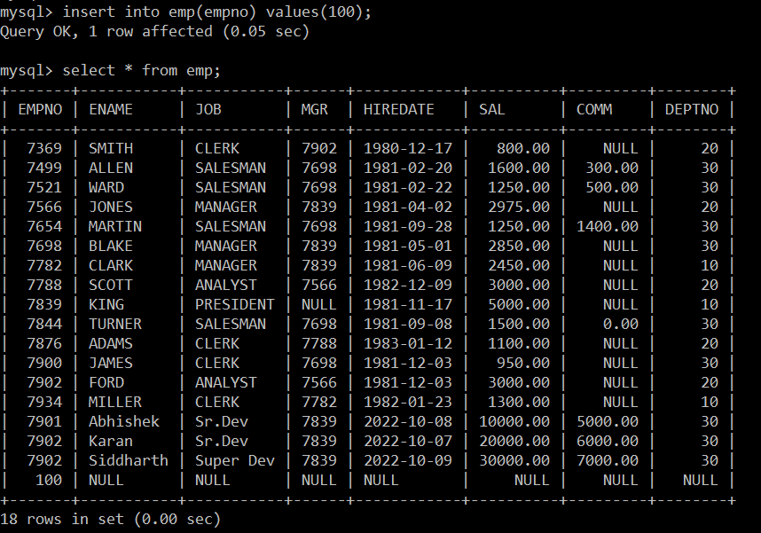

**insert row in emp with empno 101**

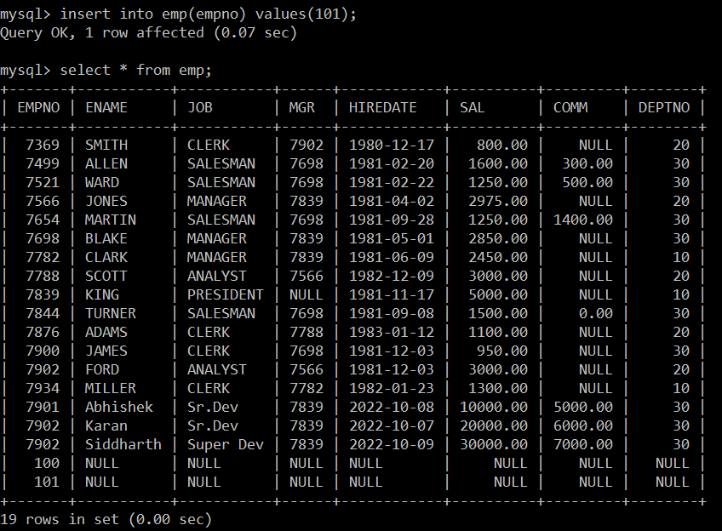

**insert row in emp with empno 102**

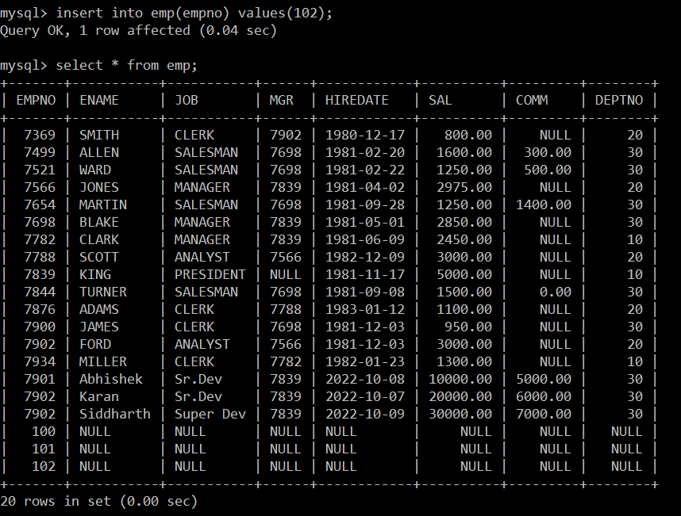

**add savepoint A**

**insert row in emp with empno 103**

**insert row in emp with empno 104**

**insert row in emp with empno 105**

**add savepoint B**

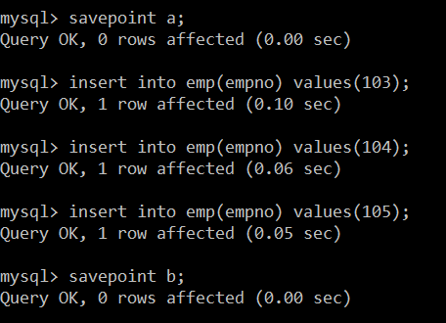

**delete emp with empno 100**

**delete emp with emp no 104**

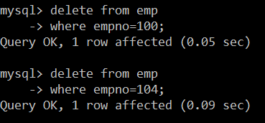

**rollback upto savepoint B**

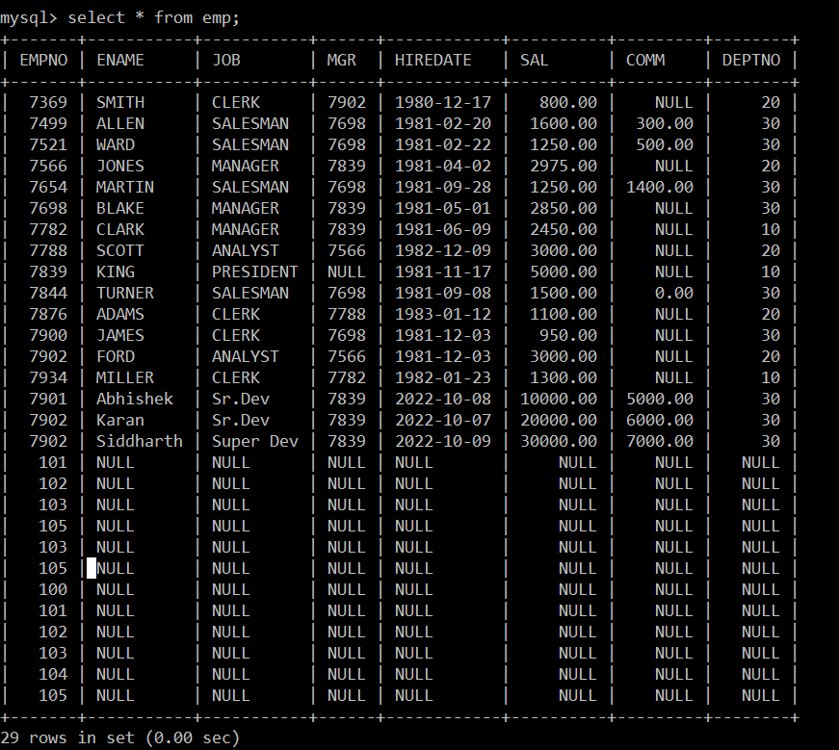

**Rollback to a**

